Please gather the following measurements to ensure an accurate modeling of the kitchen\ space

1. Length of Wall 1
2. Length Left to Right from wall to center of existing Stove placement
3. Length Left to Right from wall to center of existing Sink placement
4. Height from Floor to the Bottom of the existing Wall Cabinets
5. Height of Stove to bottom of Microwave, Exhaust fan, or upper cabinet. (if Exists)
6. Length Left to Right from wall to edge of existing Window (if exists)
7. Width of Window if exists
8. Height of Window if exists
9. Length of Wall 2
10. Height of Fridge
11. Length Right to left from wall to center of existing Fridge placement
12. Height of ceiling lowest measurement
13. Width of Kitchen Island (If Exists)
14. Width of Stove
15. Length of Island (if Exists)
16. Width of Sink
17. . . . any other Walls or Measurements you feel are necessary (Please label) in the next page  
    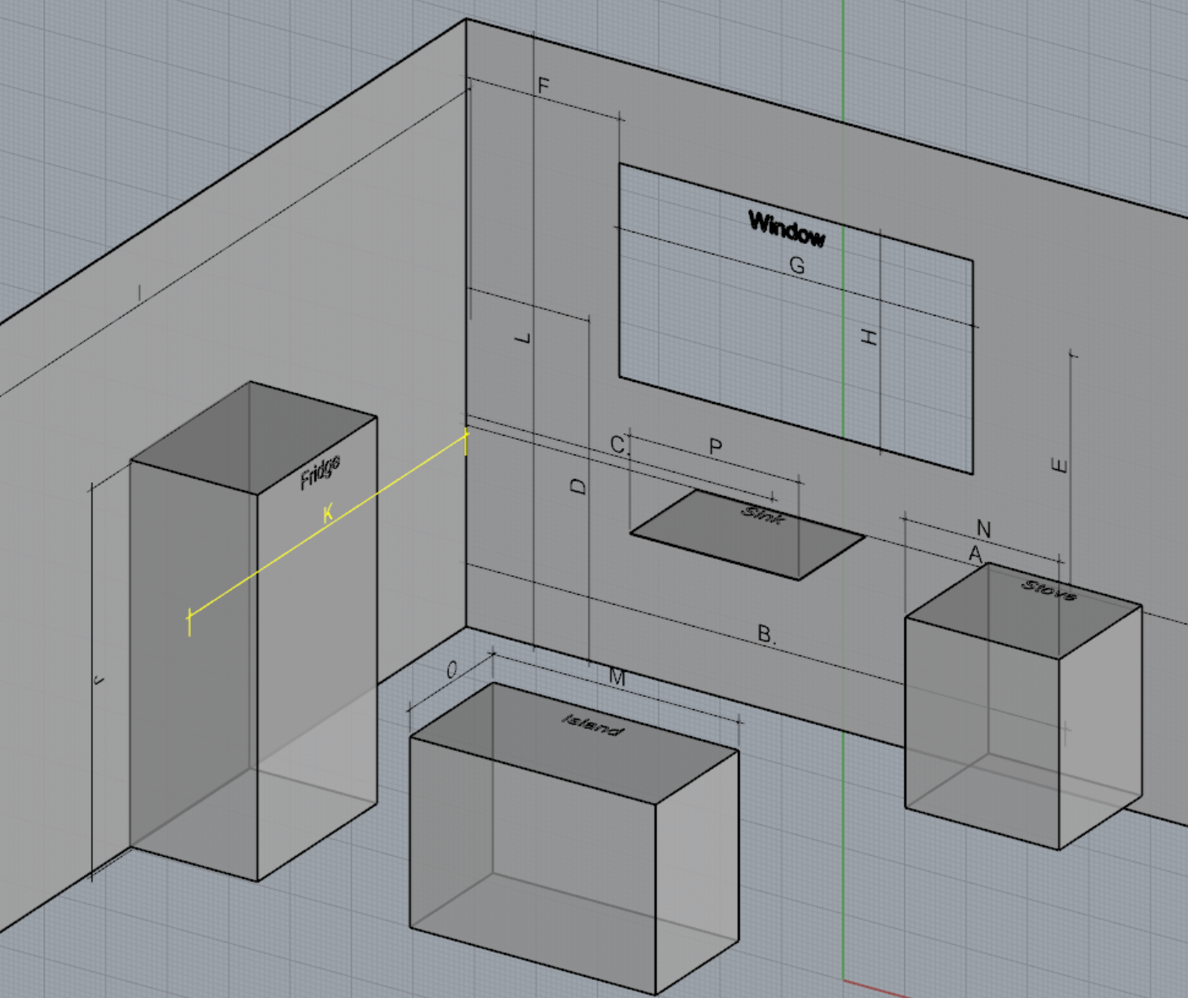

Please write down your measurements in total inches (10ft 3.5in should be written as 123.5”) in accordance to the prior sheet and submit for quote.